ESP8266 NodeMCU CP2102 Board
Description

The ESP8266 NodeMCU CP2102 board has ESP8266 which is a highly integrated chip designed for the needs of a new connected world. It offers a complete and self-contained Wi-Fi networking solution, allowing it to either host the application or to offload all Wi-Fi networking functions from another application processor.

ESP8266 has powerful on-board processing and storage capabilities that allow it to be integrated with the sensors and other application-specific devices through its GPIOs with minimal development up-front and minimal loading during runtime. Its high degree of on-chip integration allows for minimal external circuitry, and the entire solution, including the front-end module, is designed to occupy minimal PCB area.

The ESP8266 NodeMCU development board – a true plug-and-play solution for inexpensive projects using WiFi. The module arrives pre-flashed with NodeMCU firmware so they’re ready to go – just install your USB driver (below). ESP-12 Lua Nodemcu WIFI Dev Board Internet Of Things board contains a full ESP8266 WiFi module with all the GPIO broken out, a full USB-serial interface, and a power supply all on the one breadboard-friendly package.

This board is pre-flashed with NodeMCU – a Lua-based firmware for the ESP8266 which allows easy control via a neat scripting language – Lua – so you’re ready to go in just a few minutes.
The ESP-12 Lua NodeMCU WIFI Dev Board Internet Of Things with ESP8266 is an all-in-one microcontroller + WiFi platform that is very easy to use to create projects with WiFi and IoT (Internet of Things) applications.

The board is based on the highly popular ESP8266 WiFi Module chip with the ESP-12 SMD footprint. This WiFi development board already embeds in its board all the necessary components for the ESP8266 (ESP-12E) to program and upload code. It has a built-in USB to serial chip upload codes, 3.3V regulator, and logic level converter circuit so you can immediately upload codes and connect your circuits.

Features :
11 b/g/n Wi-Fi Direct (P2P), soft-AP
Integrated TCP/IP protocol stack
Open-source, Interactive, Programmable, Low-cost, Simple, Smart, Wi-Fi-enabled
Arduino-like hardware IO
Integrated low-power 32-bit CPU
Advanced API for hardware IO, which can dramatically reduce the redundant work for configuring and manipulating hardware.
Code like Arduino, but interactively in Lua script.
Nodejs style network API
Event-driven API for network applications,
which facilitates developers writing code running on a 5mm*5mm sized MCU in Nodejs style.
Greatly speed up your IOT application development process.
Lowest cost WI-FI
Less than WI-FI MCU ESP8266 integrated and easy to prototyping development kit.
We provide the best platform for IoT application development at the lowest cost.
Integrated TR switch, balun, LNA, power amplifier, and matching network
Integrated PLL, regulators, DCXO, and power management units
Onboard USB to serial chip to easily program and upload codes from the Arduino IDE
Embeds logic level converter circuits
Has an onboard 3.3V regulator to ensure enough power to function as your go-to WiFi chip!
Easy access to the GPIO pins for easy prototyping
Easy to use breadboard friendly form factor
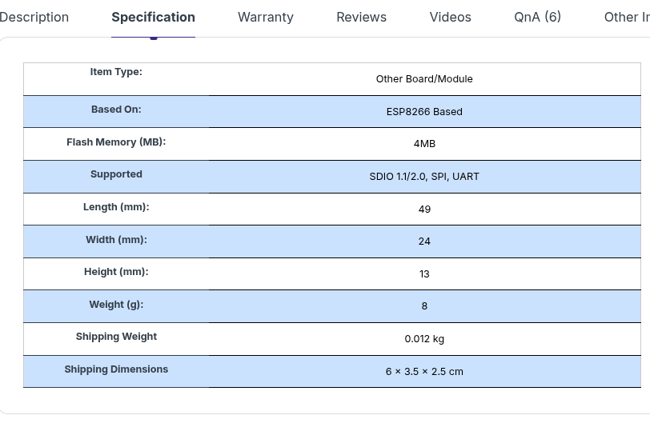
Voltage Regulator / Converter, excellent DC to DC conversion, super-efficient

